1.

| **avg_ret** | | **win_prob** | | **count_num** | **minret10** | **maxret10** |
| --- | --- | --- | --- | --- | --- | --- |
|  |  |  |  | |  |  |
| **1** | 0.007888719 | 0.517934 | 701 | | -0.3118908 | 0.493007 |

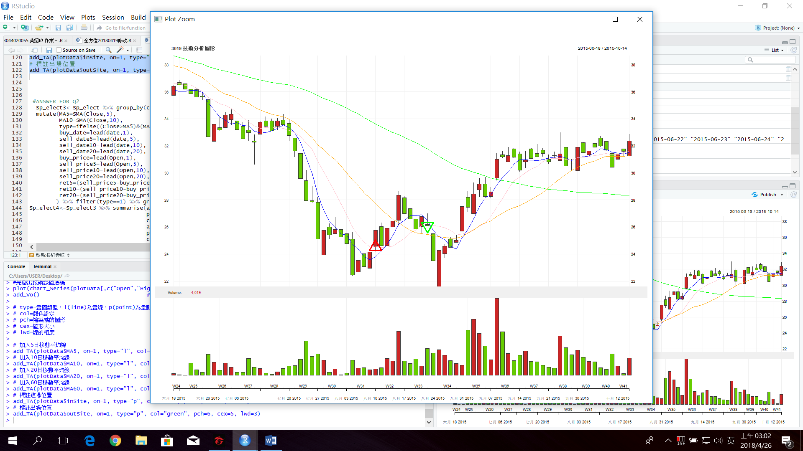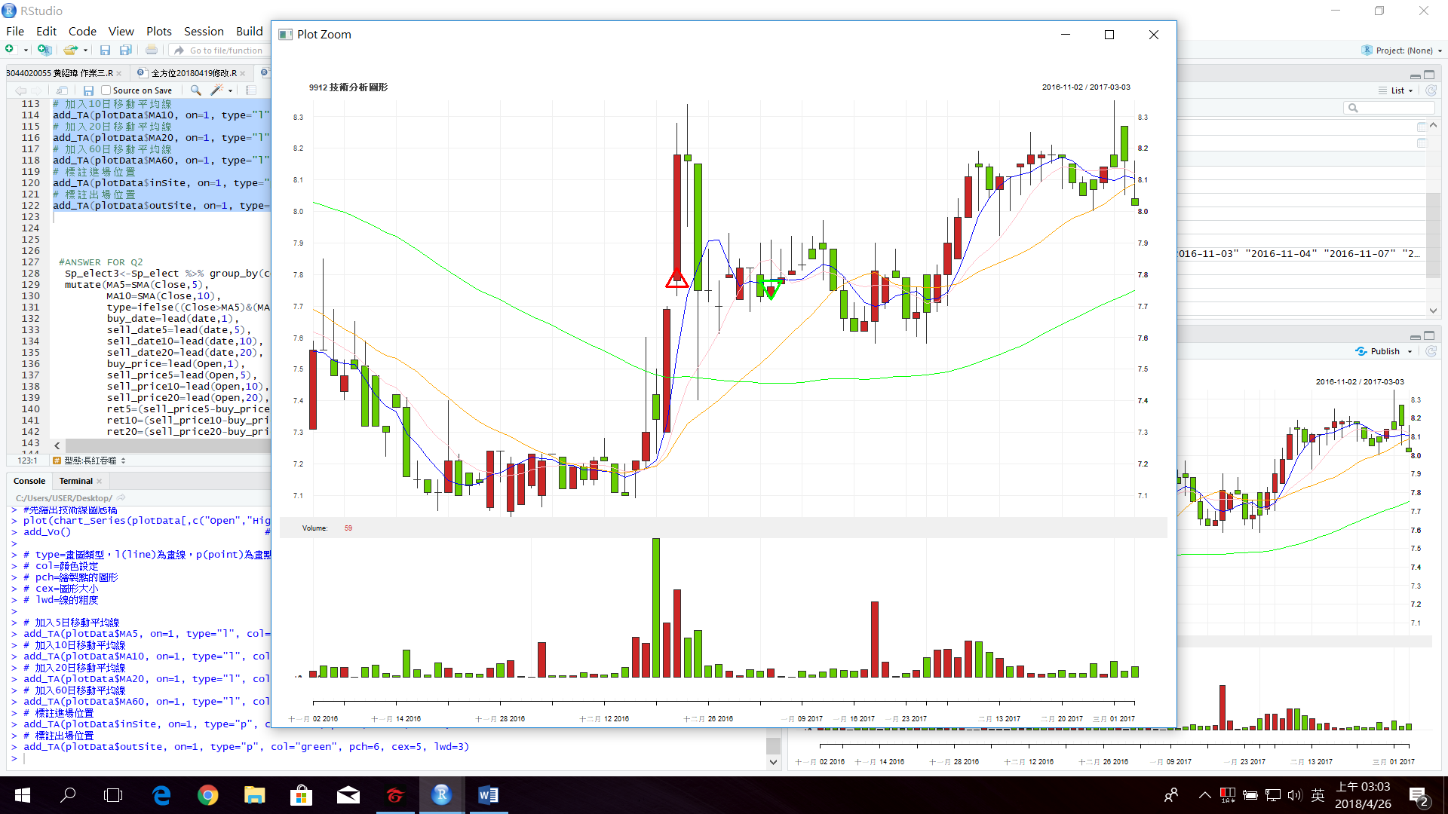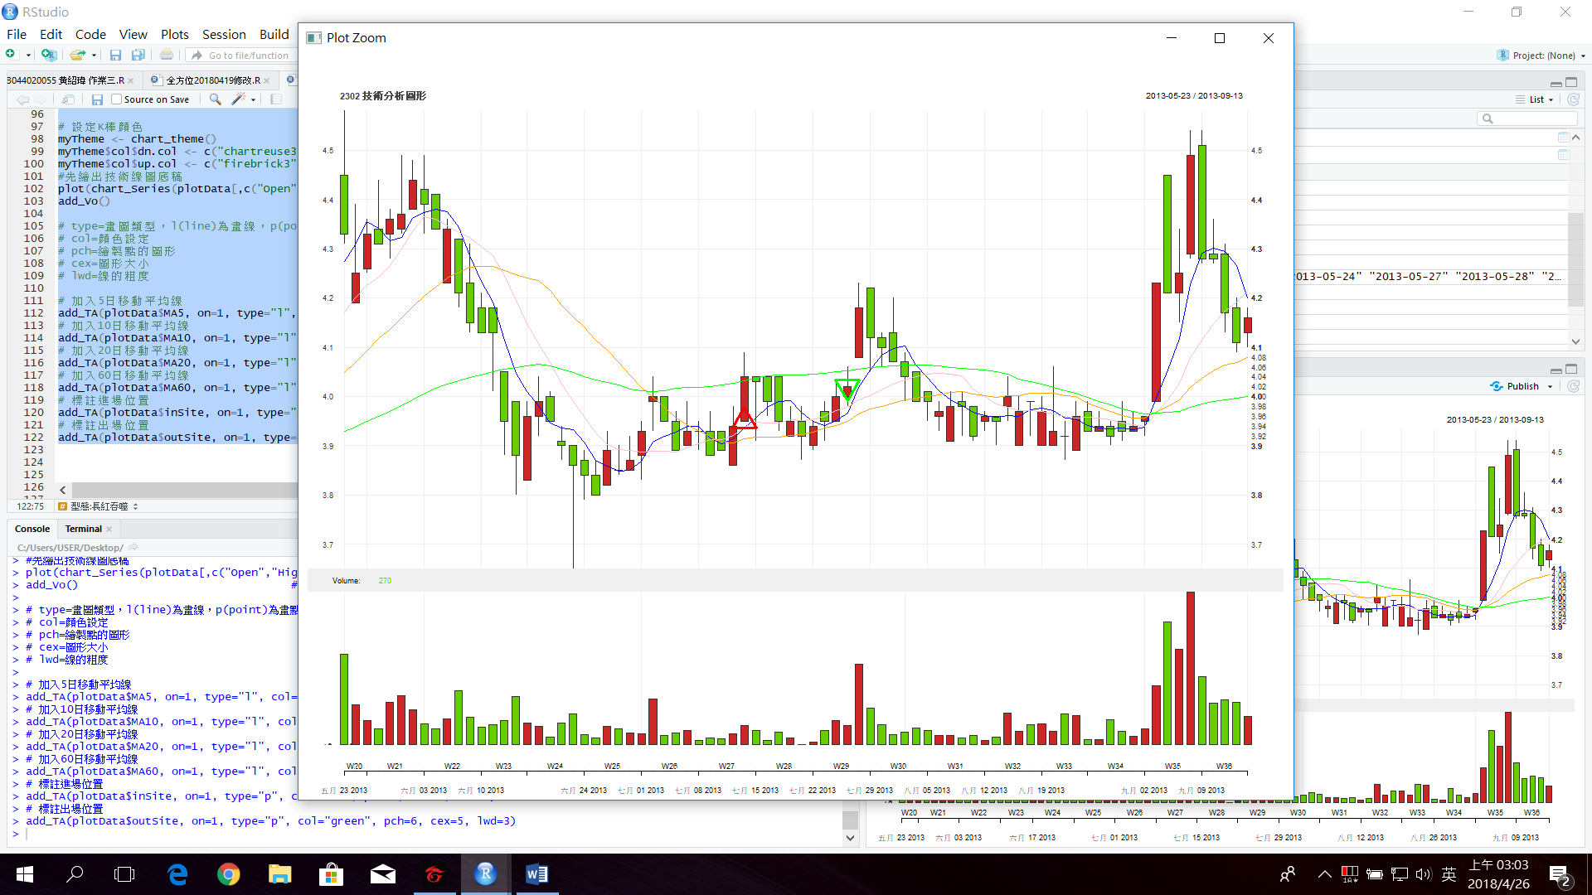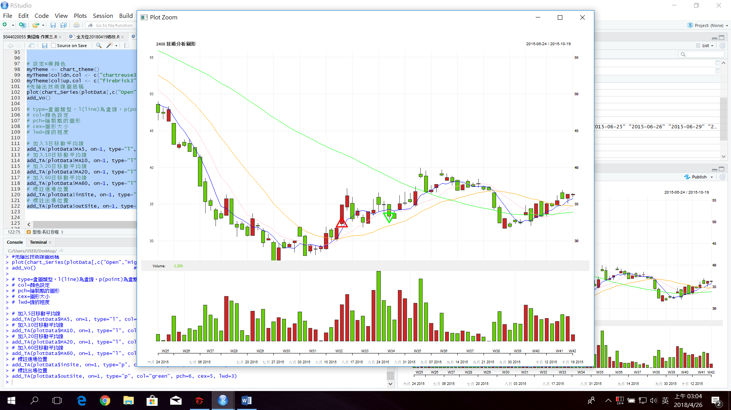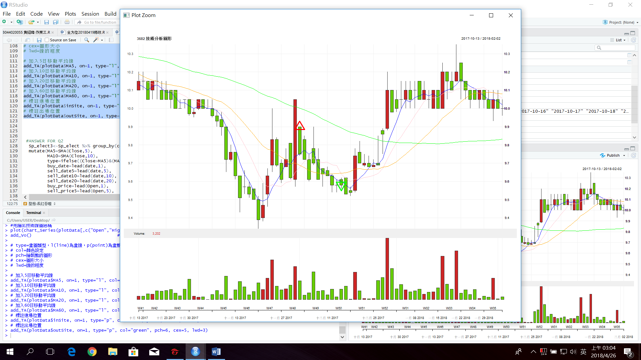

2.

